Summarize about JMeter Distributed Testing

User login to their account, at Test detail, next to “Run” Button is a “Distributed Test” button:

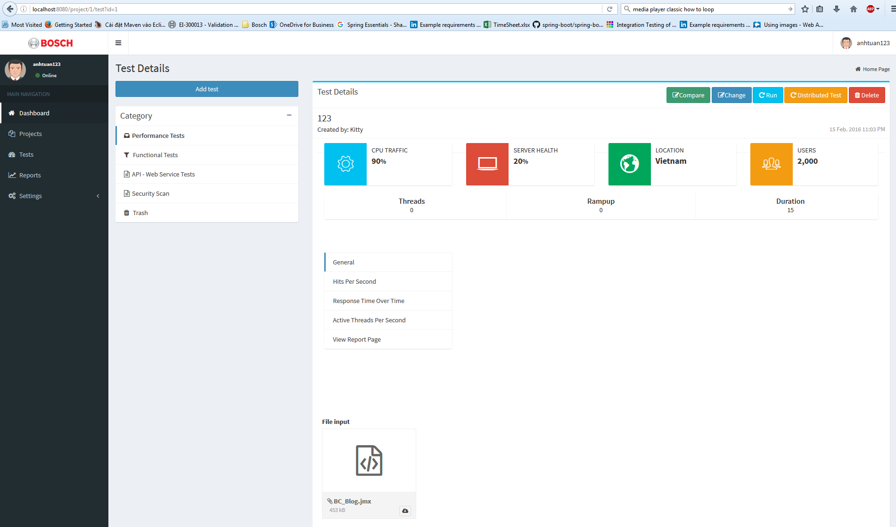

When user click on “Distributed Test” it will redirect into “Distributed Test” page view,

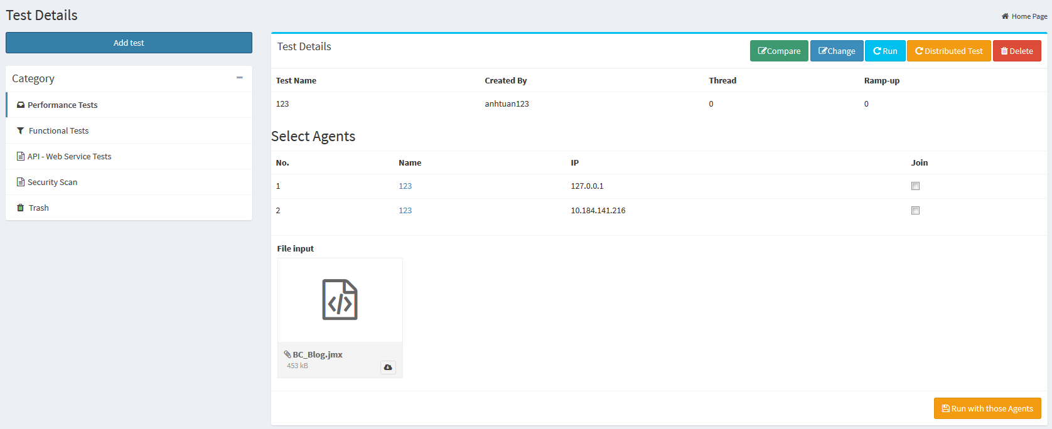

In this page, user have ability to choose which agents to run test.

The controller of Distributed test is using TestController.

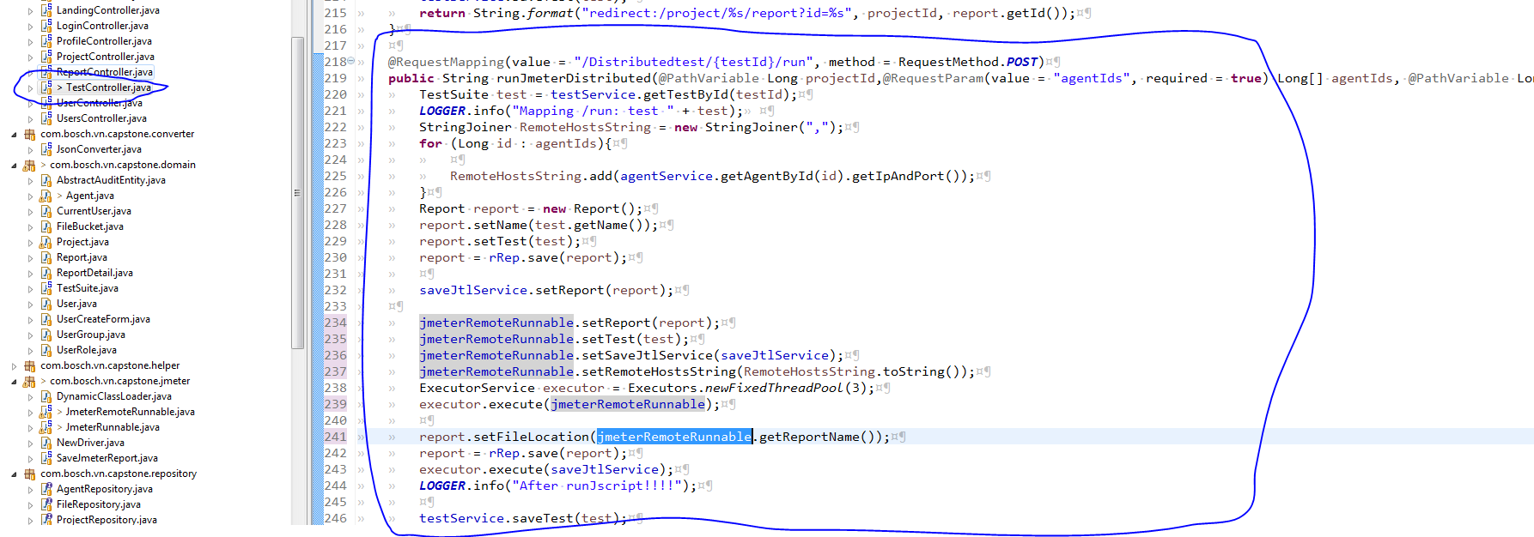

When the user hit “Distributed Test” Button, Testcontroller will run and call JMeterRemoteRunable to run it .

In JmeterRemoteRunnable, it will setting jmeter properties, remote host and run by call “startnonGui” function

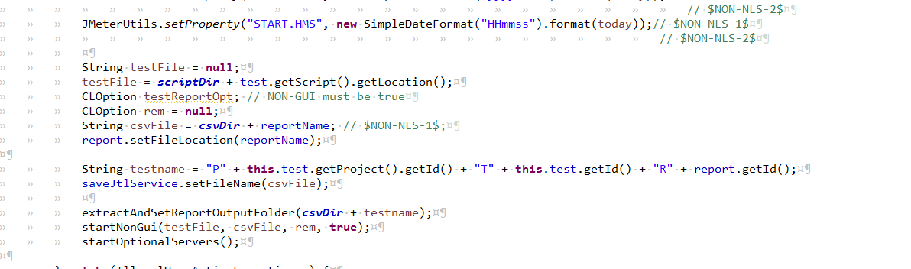

Right now everything use to call distributed testing all in JmeterRemoteRunnable.